WEINAM WEIHE GRAND BRIDGE

BRIDGE

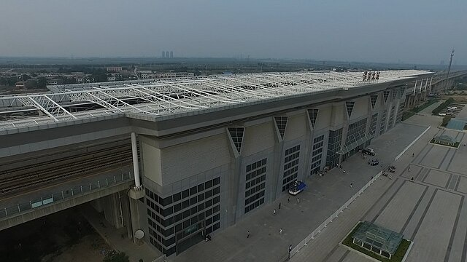

The Tianjin Grand Bridge, stretching majestically across the vast landscape of China's northern plains, is a monumental testament to human engineering and ambition. Spanning a staggering distance of approximately 113.7 kilometers (70.6 miles), this engineering marvel holds the Guinness World Record as the longest bridge in the world. It forms a crucial part of the Beijing-Shanghai High-Speed Railway, connecting the bustling metropolis of Tianjin with the historic city of Qingdao.Constructed primarily to accommodate the high-speed trains hurtling between China's capital and its economic hub, the Tianjin Grand Bridge represents a triumph of modern engineering ingenuity. Its construction required meticulous planning, cutting-edge technology, and the collaborative efforts of thousands of engineers, workers, and specialists.the bridge's design is a testament to both strength and elegance, featuring a combination of reinforced concrete viaducts, steel trusses, and prestressed concrete beams. Towering pillars rise from the earth, supporting the weight of the bridge's expansive deck as it traverses rivers, valleys, and urban landscapes.As trains thunder across its expanse at speeds exceeding 300 kilometers per hour (186 miles per hour), passengers are treated to breathtaking vistas of China's diverse landscape, from verdant plains to bustling cityscapes. Yet, amidst the speed and modernity, the bridge remains a symbol of China's ancient reverence for infrastructure, connecting not just cities but also cultures, economies, and aspirations.

